Equity Options Pricing Engine and Market Validation
Author: Amir Akhmetov
Project Type: Quantitative Finance / Derivatives Analytics
Language: Python
Data Source: Yahoo Finance (yfinance)

Executive Summary
This project develops a complete options analytics framework that combines theoretical option pricing models with real-world market data. The system implements the Black-Scholes model for European option pricing, calculates option Greeks, constructs a Cox-Ross-Rubinstein (CRR) binomial tree, recovers implied volatility using numerical methods, estimates historical volatility from stock price data, and validates results using live option-chain information from Yahoo Finance.
The project demonstrates both theoretical correctness and practical applicability. Validation tests confirmed put-call parity, successful implied volatility recovery, and convergence of the binomial tree model toward the Black-Scholes analytical solution. Furthermore, market data analysis revealed a clear volatility smile in AAPL options, illustrating one of the most important empirical deviations from Black-Scholes assumptions.

1. Introduction
Options are among the most widely traded derivative securities in modern financial markets. Accurate option valuation is critical for trading, hedging, portfolio management, and risk analysis.
The Black-Scholes model remains one of the most influential frameworks in quantitative finance due to its closed-form pricing formula for European options. However, practical implementation requires validation through numerical methods and comparison with observed market behavior.
The objectives of this project are:
- Implement the Black-Scholes pricing model.
- Compute option Greeks.
- Implement a CRR binomial tree model.
- Recover implied volatility from market prices.
- Estimate historical volatility using real stock data.
- Validate models using live market option chains.
- Investigate the volatility smile phenomenon.

2. Methodology

2.1 Black-Scholes Model
The Black-Scholes framework was implemented to price European call and put options.
Inputs:
- Spot Price (S)
- Strike Price (K)
- Time to Maturity (T)
- Risk-Free Interest Rate (r)
- Volatility (σ)
- Dividend Yield (q)
The implementation supports both call and put contracts and incorporates continuous dividend payments.

2.2 Greeks Calculation
The framework calculates the five primary Greeks:

Delta
Measures sensitivity to changes in the underlying asset price.

Gamma
Measures the rate of change of Delta.

Vega
Measures sensitivity to changes in volatility.

Theta
Measures time decay.

Rho
Measures sensitivity to interest rate changes.
These risk measures provide insight into how option values respond to changing market conditions.

2.3 Binomial Tree Model
A Cox-Ross-Rubinstein (CRR) binomial tree was implemented as a numerical alternative to Black-Scholes.
The model:
- Divides the option's life into discrete time steps.
- Simulates upward and downward stock movements.
- Computes terminal payoffs.
- Discounts expected values backward through the tree.
As the number of steps increases, the binomial model should converge toward the Black-Scholes solution.

2.4 Implied Volatility Recovery
Implied volatility was recovered using a bisection search algorithm.
The solver repeatedly adjusts volatility until:
[
BS\ Price(\sigma) = Market\ Price
]
within a specified numerical tolerance.
This procedure allows market prices to be translated into volatility estimates.

2.5 Historical Volatility Estimation
Historical volatility was estimated using one year of daily AAPL closing prices.
The procedure:
- Download daily closing prices.
- Compute logarithmic returns.
- Calculate the standard deviation of returns.
- Annualize the result using:
$$σ_{\left\{annual\right\}}=σ_{\left\{daily\right\}}√252$$

2.6 Market Data Integration
Yahoo Finance data was integrated using the yfinance package.
The system retrieves:
- Current stock prices
- Historical price series
- Option expiration dates
- Option chains
- Bid and ask prices
- Market implied volatilities
This allows direct comparison between theoretical and observed market values.

3. Validation Results

3.1 Put-Call Parity
Put-call parity was tested using Black-Scholes prices.

Results
Metric | Value
Call Price | 10.4506
Put Price | 5.5735
Difference | ~0
The parity relationship held within numerical precision, confirming correctness of the pricing implementation.

3.2 Implied Volatility Recovery
The implied volatility solver was tested by recovering a known volatility from theoretical option prices.

Results
Contract | Original IV | Recovered IV
Call | 20.00% | 20.00%
Put | 20.00% | 20.00%
The recovered values matched the original inputs exactly.
This validates the numerical implementation of the bisection algorithm.

4. Historical Volatility Analysis
Using one year of daily AAPL price data:

Result
Metric | Value
Historical Volatility | 22.33%
Historical volatility represents realized market volatility and serves as a benchmark against market-implied volatility.

5. Binomial Tree Convergence
To verify numerical correctness, a standard at-the-money European call option was priced using both Black-Scholes and the CRR binomial tree.
Parameters:
- Spot Price = 100
- Strike Price = 100
- Volatility = 20%
- Risk-Free Rate = 5%
- Maturity = 1 year

Results
Steps | Error
10 | 0.197
50 | 0.040
100 | 0.020
500 | 0.004
1000 | 0.002
2000 | 0.001

Figure 1. Binomial Tree Convergence

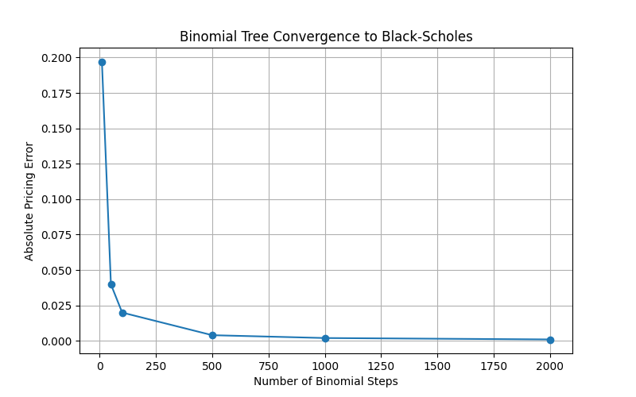

Discussion
The pricing error decreases monotonically as the number of binomial steps increases.
The steep reduction in error between 10 and 100 steps demonstrates rapid convergence. Beyond approximately 500 steps, additional increases in tree size produce only marginal improvements.
This behavior confirms that the CRR implementation converges toward the analytical Black-Scholes solution.

6. Market Option Analysis
Option-chain data were collected from Yahoo Finance using the first expiration date with at least 30 days to maturity.
For each contract the following information was retrieved:
- Strike price
- Bid price
- Ask price
- Midpoint price
- Implied volatility
- Time to maturity
The midpoint price was calculated as:
[
Mid=\frac{Bid+Ask}{2}
]
Midpoint prices were used because they provide a more stable estimate of current market value than last traded prices, which may be stale or influenced by temporary liquidity conditions.

7. Market Implied Volatility Validation
Recovered implied volatility was computed from option midpoint prices.

Example Result
Metric | Value
Market Midpoint | 11.2750
Recovered IV | 25.10%
Repriced Value | 11.2750
Error | ~0
The recovered volatility successfully reproduces the observed market price.
This confirms consistency between:
- Black-Scholes pricing
- Market data extraction
- Implied volatility recovery

8. Volatility Smile Analysis
A volatility smile was constructed using AAPL call options.
The analysis was restricted to contracts with moneyness between:
$$0.8 ≤\frac{K}{S}≤1.2$$

to remove extreme outliers and focus on actively traded strikes.

Figure 2. AAPL Implied Volatility Comparison

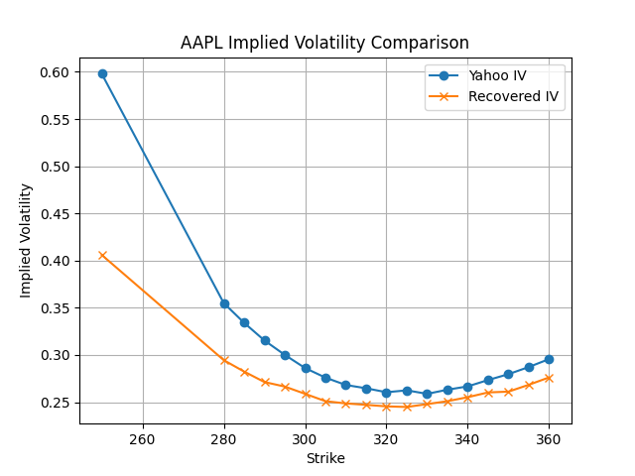

Discussion
Several observations emerge:

1. Clear Volatility Smile
Both curves exhibit a pronounced U-shaped pattern.
Implied volatility decreases toward at-the-money strikes and increases again for deep in-the-money and out-of-the-money contracts.

2. Similar Shape
The recovered implied volatility curve closely follows the Yahoo Finance curve across all strikes.
This indicates that the implemented implied volatility solver captures the same market structure observed in vendor data.

3. Systematic Level Difference
Yahoo Finance implied volatility values are consistently higher.
Possible explanations include:
- Different pricing inputs
- Alternative interpolation methods
- Exchange-provided estimates
- Vendor-specific calculation procedures

4. Black-Scholes Limitation
The volatility smile demonstrates that volatility is not constant across strikes.
This directly contradicts one of the key assumptions of the Black-Scholes model and is a well-known feature of real option markets.

9. Key Findings
- Black-Scholes pricing was implemented successfully.
- Option Greeks were computed correctly.
- Put-call parity was validated.
- Implied volatility recovery reproduced known volatility values.
- The CRR binomial tree converged toward the Black-Scholes analytical solution.
- Historical volatility differed from market-implied volatility.
- Live AAPL option data exhibited a clear volatility smile.
- Recovered implied volatility successfully reproduced market midpoint prices.

10. Conclusion
This project developed a complete options pricing and analytics framework integrating both theoretical models and live market data.
The system successfully implements:
- Black-Scholes pricing
- Greeks calculation
- Binomial tree pricing
- Implied volatility extraction
- Historical volatility estimation
- Market data integration
- Volatility smile analysis
Validation results confirmed the correctness of the implementation, while empirical analysis highlighted important real-world deviations from theoretical assumptions.
The project demonstrates practical quantitative finance skills and provides a foundation for future extensions such as:
- Volatility surfaces
- Monte Carlo simulation
- Local volatility models
- Stochastic volatility models
- American option pricing

Skills Demonstrated
- Python Programming
- Object-Oriented Design
- Numerical Methods
- Financial Derivatives
- Quantitative Modeling
- Market Data Analysis
- Data Visualization
- Black-Scholes Theory
- Binomial Tree Methods
- Implied Volatility Modeling

